AI-POWERED HR ANALYTICS & EMPLOYEE ATTRITION PREDICTION SYSTEM
A Report Submitted
In Partial Fulfilment of the Requirements
for the degree of
Bachelor of Technology (B.Tech.) in
Computer Science & Engineering

Deepanshu Goel Roll No.: 202310101110058

Under the Guidance of
Mr. Ankit Shukla
FACULTY OF COMPUTER SCIENCE & ENGENEERING
INSTITUTE OF TECHNOLOGY
SHRI RAMSWAROOP MEMORIAL UNIVERSITY


Academic Session: 2026–27
CERTIFICATE

This is to certify that the project entitled “AI-Powered HR Analytics & Employee Attrition Prediction System” has been successfully carried out by Mr. Deepanshu Goel (Roll No. 202310101110058) in partial fulfilment of the requirements for the award of the degree of Bachelor of Technology (B.Tech.) in Computer Science & Engineering at Shri Ramswaroop Memorial University, Lucknow, during the academic session 2026–27.
This project is an original work and has not been submitted elsewhere for the award of any other degree.
Project Guide
Faculty, Department of Computer Science & Engineering
Signature: __________

DECLARATION

I, Deepanshu Goel (Roll No. 202310101110058), hereby declare that the project entitled “AI-Powered HR Analytics & Employee Attrition Prediction System” submitted in partial fulfilment of the requirements for the award of the degree of Bachelor of Technology (B.Tech.) in Computer Science & Engineering at Shri Ramswaroop Memorial University is my original work.
I further declare that this project has not been submitted previously, either in whole or in part, for the award of any degree or diploma in any university or institution. All sources used have been properly acknowledged.

Place: Lucknow Deepanshu Goel
Date: __________ Roll No.: 202310101110058

ACKNOWLEDGEMENT

First and foremost, I express my heartfelt gratitude to Almighty God for blessing me with good health, patience, strength, and determination to complete this project successfully.
I am deeply thankful to my Project Guide, MR. Ankit Shukla, for providing valuable guidance, continuous encouragement, constructive suggestions, and technical support throughout the development of this project. Their knowledge, motivation, and timely feedback helped me complete the project effectively.
I would also like to express my sincere gratitude to the Head of the Department, all respected faculty members, and the management of Shri Ramswaroop Memorial University for providing the necessary facilities, academic environment, and constant support during the course of this project.
Finally, I would like to express my heartfelt thanks to my parents, family members, friends, and classmates for their continuous encouragement, moral support, and motivation throughout the completion of this project.
I sincerely acknowledge everyone who directly or indirectly contributed to the successful completion of this project.
Place: ___________________
Date: ____________________

ABSTRACT

Human Resource (HR) Analytics has emerged as a crucial domain for organizations seeking to improve employee performance, workforce planning, and retention strategies through data-driven decision-making. Employee attrition is one of the major challenges faced by organizations, as high turnover rates lead to increased recruitment costs, reduced productivity, and loss of experienced talent. Predicting employee attrition at an early stage enables organizations to implement effective retention strategies and improve overall organizational performance. This project, titled "AI-Powered HR Analytics & Employee Attrition Prediction System Using Python, Machine Learning, MySQL, SQL, and Microsoft Power BI," presents a comprehensive solution for analysing employee data, predicting attrition, and generating meaningful business insights.
The project is developed using the IBM HR Analytics Employee Attrition & Performance Dataset, which contains employee-related information such as age, gender, department, education, job role, monthly income, overtime, work-life balance, performance rating, years at the company, and attrition status. The implementation begins with data preprocessing and cleaning using Python, where missing values, duplicate records, and inconsistencies are identified and handled to ensure high-quality data for analysis. Exploratory Data Analysis (EDA) is then performed using various statistical techniques and visualizations to identify patterns, trends, and relationships among employee attributes influencing attrition.
The model is trained and evaluated using standard performance metrics such as accuracy, confusion matrix, classification report, and feature importance analysis. The prediction model assists HR professionals in identifying employees who are more likely to leave the organization, thereby enabling timely intervention and better workforce management.
For efficient data storage and analysis, MySQL is used as the relational database management system. Employee records are organized within the database, and SQL queries are executed to perform department-wise analysis, salary analysis, gender distribution, overtime analysis, job role analysis, and attrition analysis. These analytical reports provide valuable business insights that support strategic HR decision-making.

TABLE OF CONTENTS

CHAPTERS PAGE NO.
CERTIFICATE i
DECLARATION ii
ACKNOWLEDGEMENT iii
ABSTRACT iv
TABLE OF CONTENT v
CHAPTER I: INTRODUCTION 1-5
  - PROJECT NAME (About the project) 1
  - PREFACE (Background About the project) 2
  - DEFINITION OF PROJECT TECHNOLOGY 3
  - NEED OF PROJECT 4
  - SCOPE OF PROJECT 5
CHAPTER II: REQUIREMENTS ANALYSIS 6-14
2.1 INFORMATION GATHERING 6
2.2 FUNCTIONAL REQUIREMENTS 7
2.3 NON-FUNCTIONAL REQUIREMENTS 10
2.3.1 SOFTWARE REQUIREMENTS 10
2.3.2 USABILITY REQUIREMENTS
2.3.3 SECURITY REQUIREMENTS
2.4 FEASIBILITY STUDY
2.4.1 TECHNICAL FEASIBILITY
2.4.2 OPERATIONAL FEASIBILITY
2.4.3 ECONOMICAL FEASIBILITY

CHAPTER III: SYSTEM ANALYSIS AND DESIGN 15-24

3.1 PROJECT WORKFLOW
3.2 USE CASE DIAGRAM
3.3 SNAPSHOTS
CHAPTER IV: TESTING 25-32
4.1 ABOUT THE TECHNOLOGY USED
4.2 TESTING
4.2.1 UNIT TESTING
4.2.2 INTEGRATION TESTING
4.2.3 SYSTEM TESTING
CHAPTER V: ADVANTAGES AND LIMITATIONS OF 33-37
THE DEVELOPED SYSTEM
5.1 ADVANTAGES OF DEVELOPED SYSTEM
5.2 LIMITATIONS OF DEVELOPED SYSTEM
CHAPTER VI: RESULTS, CONCLUSION 38-40
6.1 RESULT OBTAINED
6.2 FUTURE SCOPE
6.3 RECOMMENDATION
CONCLUSION………………………. 41
REFERENCES.................................. 42

LIST OF FIGURES

Figure No. | Figure Title | Page No.
Fig 3.1 | SQL Output – Total Employees, Attrition, Attrition Rate, Average Age, Average Income, Department-wise Employees, Job Role Analysis and Overtime Analysis | 26
Fig 3.2 | Confusion Matrix of the Employee Attrition Prediction Model | 26
Fig 3.3 | Top 10 Important Features Influencing Employee Attrition | 27
Fig 3.4 | Registration Interface | 28
Fig 3.5 | HR Employee Analytics Dashboard | 29
Fig 3.6 | ML Prediction Form | 30
Fig 3.7 | High-Risk Employee Monitoring | 30
Fig 3.8 | Power BI Dashboard | 31

CHAPTER I
INTRODUCTION
IBM HR Analytics – Employee Attrition Prediction System
The IBM HR Analytics – Employee Attrition Prediction System is a web-based Human Resource Analytics and Machine Learning application developed to analyse employee data and predict the risk of employee attrition. Employee attrition occurs when employees leave an organization, which can lead to increased recruitment costs, loss of experienced employees, productivity issues, and workforce instability.
The system uses the IBM HR Employee Attrition dataset to analyse various employee-related attributes and identify patterns associated with attrition. Important factors considered in the prediction system include Age, Monthly Income, Job Satisfaction, Overtime, Years at Company, and Job Level.
A Random Forest Machine Learning algorithm is used to predict whether an employee is likely to leave the organization. The system also calculates an attrition risk percentage and categorizes employees into Low, Medium, and High-Risk levels. This enables HR users to identify employees who may require further attention and analysis.
The project provides an interactive HR Analytics Dashboard containing important workforce indicators such as total employees, employees who have left, attrition rate, average monthly income, department-wise analysis, job-role distribution, employee satisfaction analysis, and high-risk employee monitoring.
To make the Machine Learning predictions more understandable, the system incorporates Explainable Artificial Intelligence (XAI) using SHAP (Shapley Additive explanations). SHAP identifies the factors that have contributed to an individual prediction, allowing HR users to understand why a particular employee has been assigned a particular risk level.
The system is developed using technologies including Python, Fast API, Machine Learning, MySQL, HTML, CSS, JavaScript, Chart.js, and SHAP. A Power BI dashboard is also included to provide interactive business intelligence and visualization.
The primary purpose of the project is to integrate HR Analytics, Machine Learning, Database Management, Web Development, and Explainable AI into a single platform that can assist HR professionals in analysing workforce data and supporting data-driven employee retention and workforce planning.
1.2 PREFACE – BACKGROUND ABOUT THE PROJECT
The IBM HR Analytics – Employee Attrition Prediction System has been developed with this objective. The project uses historical employee information to perform exploratory analysis, generate HR insights, and develop a Machine Learning model for attrition prediction. The IBM HR dataset contains 1,470 employee records and 35 attributes, providing information about employee demographics, job characteristics, income, satisfaction, overtime, experience, and other HR-related factors.
The system processes the employee data and uses selected features such as Age, Monthly Income, Job Satisfaction, Overtime, Years at Company, and Job Level for the prediction workflow. The trained Random Forest model produces an attrition prediction along with a probability-based risk percentage.
The project also provides an AI Risk Monitoring feature through which HR users can identify employees categorized as high risk. In addition, the SHAP-based explanation module provides information about the factors influencing individual predictions. This improves transparency and helps users interpret Machine Learning results.
The dashboard presents HR information through charts, KPI cards, employee search functionality, prediction results, and risk monitoring. The integration of Power BI further supports interactive data visualization and business intelligence analysis.
Thus, the project demonstrates how modern technologies can be combined to create an integrated HR analytics solution. It provides a foundation for using historical employee data, predictive modelling, and explainable AI as decision-support mechanisms for HR analysis and workforce planning.
1.3 DEFINITION OF PROJECT TECHNOLOGY
The project uses a combination of programming languages, frameworks, databases, Machine Learning libraries, visualization tools, and Explainable AI technologies.
1. Python -Python is the primary programming language used in the project. It is used for data preprocessing, exploratory data analysis, Machine Learning model development, prediction logic, and backend development.
2. Pandas
Pandas is a Python library used for data manipulation and analysis. It is used to read the IBM HR dataset, clean and transform employee records, select required features, and perform statistical analysis.
3. Scikit-learn
Scikit-learn is a Machine Learning library used for data preprocessing, splitting the dataset into training and testing sets, model training, prediction, and performance evaluation.
4. Random Forest
Random Forest is an ensemble Machine Learning algorithm consisting of multiple decision trees. In this project, it is used to predict employee attrition based on selected employee attributes and generate probability-based risk information.
5. SHAP
SHAP (Shapley Additive explanations) is an Explainable AI technique used to interpret Machine Learning predictions. It helps identify which employee attributes have contributed to a particular prediction.
6. Fast API
Fast API is a modern Python web framework used to develop the backend REST APIs of the system. It handles requests from the frontend and provides services such as employee prediction, dashboard data, employee search, database testing, and explanations.
7. MySQL
MySQL is a relational database management system used for storing and managing structured employee and application-related data. It allows the backend to perform database operations using SQL.
8. HTML, CSS and JavaScript
HTML is used to structure the web pages, CSS is used for styling and responsive design, and JavaScript is used to provide interactive functionality and communicate with backend APIs.
9. Chart.js
Chart.js is a JavaScript-based visualization library used to display interactive charts for HR analytics, including attrition distribution, department analysis, job-role analysis, employee demographics, and other workforce metrics.
10. Power BI
Microsoft Power BI is a Business Intelligence and data visualization platform used in the project to create interactive HR dashboards and present analytical insights through charts, KPIs, filters, and visual reports.
11. Uvicorn
Uvicorn is an ASGI server used to run the Fast API backend application during development and testing.
In conclusion, this project highlights the importance of combining predictive analytics with interactive visualization tools to transform traditional HR reporting into intelligent decision-making systems. The developed solution contributes to modern HR management by providing accurate, data-driven insights that support strategic workforce planning and employee retention initiatives.
1.4 Need of the Project
The need for this project arises from the growing demand for intelligent HR decision-support systems capable of predicting employee attrition before it occurs. Such systems enable HR departments to implement preventive strategies, improve employee engagement, optimize workforce planning, and reduce unnecessary recruitment expenses.
The proposed AI-powered HR Analytics system fulfils this requirement by integrating Python-based data analytics, machine learning algorithms, SQL database analysis, and interactive Power BI dashboards into a unified analytical framework. The system assists HR managers in identifying high-risk employees, monitoring workforce performance, and making informed business decisions based on real-time analytical insights.
In addition to organizational benefits, the project also demonstrates the practical implementation of Artificial Intelligence, Data Science, Machine Learning, Database Management Systems, SQL, and Business Intelligence tools within a real-world business application. Therefore, the project has both academic significance and industrial relevance.

1.5 Scope of the Project
The scope of this project focuses on analyzing employee-related information using Artificial Intelligence, Machine Learning, Database Management Systems, and Business Intelligence tools. The project is limited to the IBM HR Analytics Employee Attrition dataset, which contains historical employee information from various organizational departments.
The project includes:
- Employee data preprocessing and cleaning using Python.
- Exploratory Data Analysis to understand workforce characteristics.
- Machine Learning model development for employee attrition prediction.
- SQL-based HR analytics using MySQL.
- Interactive Power BI dashboard development.

CHAPTER II
REQUIREMENTS ANALYSIS AND FEASIBILITY STUDY
Requirements analysis is an important phase of software development in which the requirements of the proposed system are identified, analysed, and documented. For the IBM HR Analytics – Employee Attrition Prediction System, the requirements were defined according to the needs of HR users, employee data analysis, Machine Learning-based attrition prediction, database management, dashboard visualization, and Explainable AI.
The purpose of this chapter is to review previous studies related to employee attrition prediction, compare different machine learning approaches, identify their advantages and limitations, and establish the research gap addressed by the proposed project.
2.1 INFORMATION GATHERING
Information gathering was performed to understand the HR problem, employee attrition patterns, dataset characteristics, user requirements, and technical requirements of the proposed system.
The following sources and activities were considered during information gathering:
1. Dataset Analysis
The IBM HR Employee Attrition dataset was studied to understand the available employee attributes and their relationship with employee attrition. The dataset contains 1,470 employee records and 35 attributes.
Important attributes include:
- Age
- Monthly Income
- Job Satisfaction
- Overtime
- Years at Company
- Job Level
- Department
2. HR Problem Analysis
Employee attrition can result in recruitment costs, loss of experienced employees, productivity issues, and workforce instability. Therefore, the system focuses on identifying patterns in employee data that may be associated with attrition.
3. User Requirement Analysis
The primary user of the system is the HR professional/HR department. The system therefore requires:
- An easy-to-use dashboard.
- Employee data analysis.
- Employee search and filtering.
- Attrition prediction.
- Risk percentage calculation.
- High-risk employee monitoring.
- Explanation of prediction results.
- Interactive charts and reports.
4. Technology Requirement Analysis
The project requires technologies capable of handling data processing, Machine Learning, API development, database management, visualization, and Explainable AI.
The major technologies selected are Python, Pandas, Scikit-learn, Random Forest, SHAP, Fast API, MySQL, HTML, CSS, JavaScript, Chart.js, and Power BI.
2.2 FUNCTIONAL REQUIREMENTS
Functional requirements describe the operations that the system must perform.
1. User Authentication
The system should provide a login/registration mechanism where authentication is implemented. The system should validate user credentials before providing access to protected HR information.
2. HR Dashboard
The system should provide an interactive dashboard displaying important HR metrics such as:
- Total Employees
- Employees Who Left
- Attrition Rate
- Average Monthly Income
- Department-wise employee distribution
- Job-role distribution
- Gender distribution
- High-risk employee information
3. Employee Data Management
The system should be capable of loading and processing employee information from the IBM HR dataset and/or connected database.
4. Employee Search
The system should allow HR users to search and filter employees based on available attributes such as:
- Department
- Job Role
- Gender
- Overtime
- Attrition status
5. Employee Attrition Prediction
The system should accept relevant employee information and generate an attrition prediction using the trained Machine Learning model.
The six primary prediction features used in the implemented workflow are:
- Age
- Monthly Income
- Job Satisfaction
- Overtime
- Years at Company
- Job Level
6. Risk Percentage Calculation
The system should use the model's prediction probability to calculate an employee's attrition risk percentage.
7. Risk Classification
The system should classify employees into three risk categories:
- Low Risk: Risk percentage below 35%
- Medium Risk: Risk percentage from 35% to below 65%
- High Risk: Risk percentage of 65% or above
8. High-Risk Employee Monitoring
The system should provide a dedicated view for identifying employees categorized as high risk so that HR users can review them more closely.
9. Explainable AI
The system should provide SHAP-based explanations for supported predictions. The explanation should identify important employee features contributing to the prediction.
10. Prediction History
The system should maintain and display prediction history where implemented, allowing users to review previously generated prediction results.
11. Database Connectivity
The backend should connect with the MySQL database and perform required database operations such as retrieving employee information and executing database queries.
12. API Services
The Fast API backend should provide services for:
- Health checking
- Database testing
- Employee search
- High-risk employee retrieval
- Attrition prediction
- SHAP explanation
13. Data Visualization
The system should present HR information using interactive charts and visualizations through technologies such as Chart.js.
2.3 NON-FUNCTIONAL REQUIREMENTS
2.3.1 SOFTWARE REQUIREMENTS
Operating System
- Windows 10/11 or equivalent operating system.
Programming Language
- Python 3.13.x
Backend Technologies
- Fast API
- Uvicorn
- SQL Alchemy
- MySQL
Machine Learning and Data Analytics
- Pandas
- NumPy
- Scikit-learn
- Joblib
- SHAP
- Matplotlib
Database
- MySQL 8.0
Frontend
- HTML5
- CSS3
- JavaScript
- Chart.js
Business Intelligence
- Microsoft Power BI
Development Tools
- Visual Studio Code or equivalent IDE
- Web browser such as Google Chrome or Microsoft Edge
- Command Prompt/PowerShell
2.3.2 USABILITY REQUIREMENTS
The system should be simple and easy to use for HR professionals who may not have technical knowledge of Machine Learning.
The following usability requirements are considered:
- The dashboard should have a clear and organized interface.
- Important HR metrics should be visible through KPI cards.
- Charts should be easy to understand.
- Prediction forms should contain clearly labelled fields.
- Prediction results should display risk percentage and risk level clearly.
- SHAP explanations should be presented in an understandable format.
2.3.3 SECURITY REQUIREMENTS
Since HR systems handle employee-related information, security is an important requirement.
The system should consider the following security measures:
- Authentication: Only authorized users should access protected HR information.
- Authorization: Different user roles can be provided with appropriate permissions.
- Database Security: Database credentials should not be hard-coded in publicly accessible source code.
- API Security: Backend endpoints should be protected where required.
- Data Privacy: Employee information should only be accessible to authorized users.
- Secure Deployment: HTTPS should be used when the application is deployed publicly.
- Secret Protection: API keys, database credentials, and authentication secrets should not be uploaded to public repositories.
2.4 FEASIBILITY STUDY
A feasibility study determines whether the proposed IBM HR Analytics – Employee Attrition Prediction System can be successfully developed and operated using the available resources.
The feasibility of the project is analysed in terms of:
- Technical Feasibility
- Operational Feasibility
- Economic Feasibility
2.4.1 TECHNICAL FEASIBILITY
The project is technically feasible because all the technologies required for development are available and compatible with each other.
Python provides libraries such as Pandas and Scikit-learn for data processing and Machine Learning. The Random Forest model can be trained and executed on a standard computer without requiring specialized hardware.
Fast API provides a lightweight backend framework for developing REST APIs, while MySQL provides structured database storage. HTML, CSS, JavaScript, and Chart.js support the development of the interactive web dashboard.
SHAP provides Explainable AI capabilities that help interpret Machine Learning predictions. Power BI provides additional business intelligence and visualization capabilities.
Therefore, the project can be developed and operated using commonly available hardware and software resources.
Conclusion: The proposed system is technically feasible.
2.4.2 OPERATIONAL FEASIBILITY
Operational feasibility determines whether the system can be effectively used in a real working environment.
The proposed system provides HR users with a centralized dashboard instead of requiring them to manually analyse large employee datasets. Important information such as attrition rate, employee distribution, employee risk level, and prediction results is presented in an easy-to-understand format.
The high-risk employee monitoring feature can help HR users identify records that require further review. SHAP explanations can also help users understand the factors associated with a prediction.
The system is designed as a decision-support system. It does not automatically make employment decisions. HR professionals should review predictions together with organizational policies, employee context, and other relevant information.
Conclusion: The proposed system is operationally feasible.
2.4.3 ECONOMICAL FEASIBILITY
The project is economically feasible because most of the technologies used are open-source or freely available for academic development.
The major technologies used, such as Python, Pandas, Scikit-learn, Fast API, MySQL, SHAP, HTML, CSS, JavaScript, and Chart.js, can be used without significant software licensing costs for a student project.
The project can also be developed using existing computer hardware without requiring expensive servers or GPU infrastructure.
Conclusion: The proposed system is economically feasible for academic development and can be expanded to a production environment according to organizational requirements.

CHAPTER III
SYSTEM ANALYSIS AND DESIGN
System analysis is the process of studying the requirements, workflow, components, data flow, and functionality of the proposed system. The IBM HR Analytics – Employee Attrition Prediction System is designed as an integrated web-based application that combines Human Resource Analytics, Machine Learning, Database Management, Explainable AI, and Business Intelligence.
3.1 Project Workflow
The project follows the workflow shown below.
IBM HR Dataset
│
▼
Data Collection
│
▼
Data Cleaning & Preprocessing
│
▼
Exploratory Data Analysis (EDA)
│
▼
Machine Learning Model
│
▼
Employee Attrition Prediction
│
▼
MySQL Database Analysis
│
▼
Power BI Dashboard
│
▼
Business Insights
1. Data Collection
The employee dataset used in this project is the IBM HR Analytics Employee Attrition Dataset. It contains information related to employee demographics, job profile, salary, performance, experience, and organizational behaviour.
The dataset consists of approximately 1,470 employee records with 35 attributes, including:
- Age
- Attrition
- Department
- Job Role
- Gender
- Monthly Income
- Overtime
The dataset provides sufficient information to analyse employee behaviour and predict attrition.
2. Data Preprocessing
Raw data often contains inconsistencies, duplicate records, and formatting issues that may reduce model accuracy. Therefore, data preprocessing was performed before model development.
The following preprocessing steps were carried out:
- Removal of unnecessary columns
- Verification of missing values
- Data type correction
- Encoding categorical variables
These preprocessing steps improved data quality and enhanced machine learning performance.
3.Machine Learning Module
The Machine Learning module is the core component of the system.
A Random Forest classifier is trained using selected employee attributes. The implemented six-feature model uses:
- Age
- Monthly Income
- Job Satisfaction
- Overtime
- Years at Company
- Job Level
The model predicts whether an employee is likely to experience attrition and also provides probability information that is used to calculate the employee's risk percentage.
The six-feature model was trained using an 80:20 training-testing split. The test accuracy obtained for this implementation was approximately 77.55%.
4. Risk Analysis Module
After obtaining the probability from the Machine Learning model, the system calculates an employee's attrition risk percentage.
The implemented risk classification is:
Risk Percentage | Risk Level
Below 35% | Low
35% to below 65% | Medium
65% and above | High
This classification provides a simple way for HR users to understand the prediction output.
5.Employee Search Module
The system provides employee search and filtering functionality.
HR users can filter employee records using available attributes such as:
- Department
- Job Role
- Gender
- Overtime
- Attrition
This allows HR users to focus on specific employee groups.
6.Backend API Module
The backend is developed using Fast API.
The major API endpoints implemented in the project include:
API Endpoint | Purpose
/ | Provides basic application/model/dataset status
/health | Checks system and model health
/db-test | Tests MySQL database connectivity
/dashboard-summary | Provides dashboard KPI and analytical data
/high-risk-employees | Retrieves high-risk employee information
/employees/search | Searches and filters employee records

7.SQL Query Outputs (MySQL — HR Analytics database)
The following screenshots show the actual output of the SQL queries executed on the employee attrition table during the training, covering employee counts, attrition rate, department/gender/job-role-wise analysis, salary statistics, and satisfaction metrics.
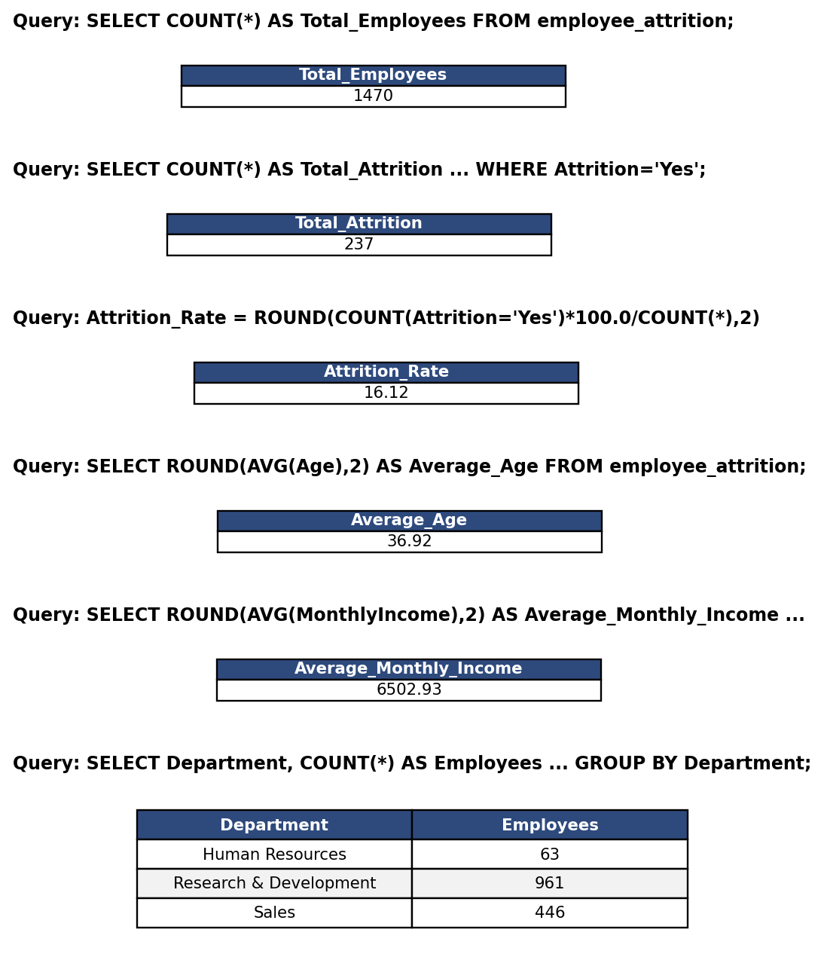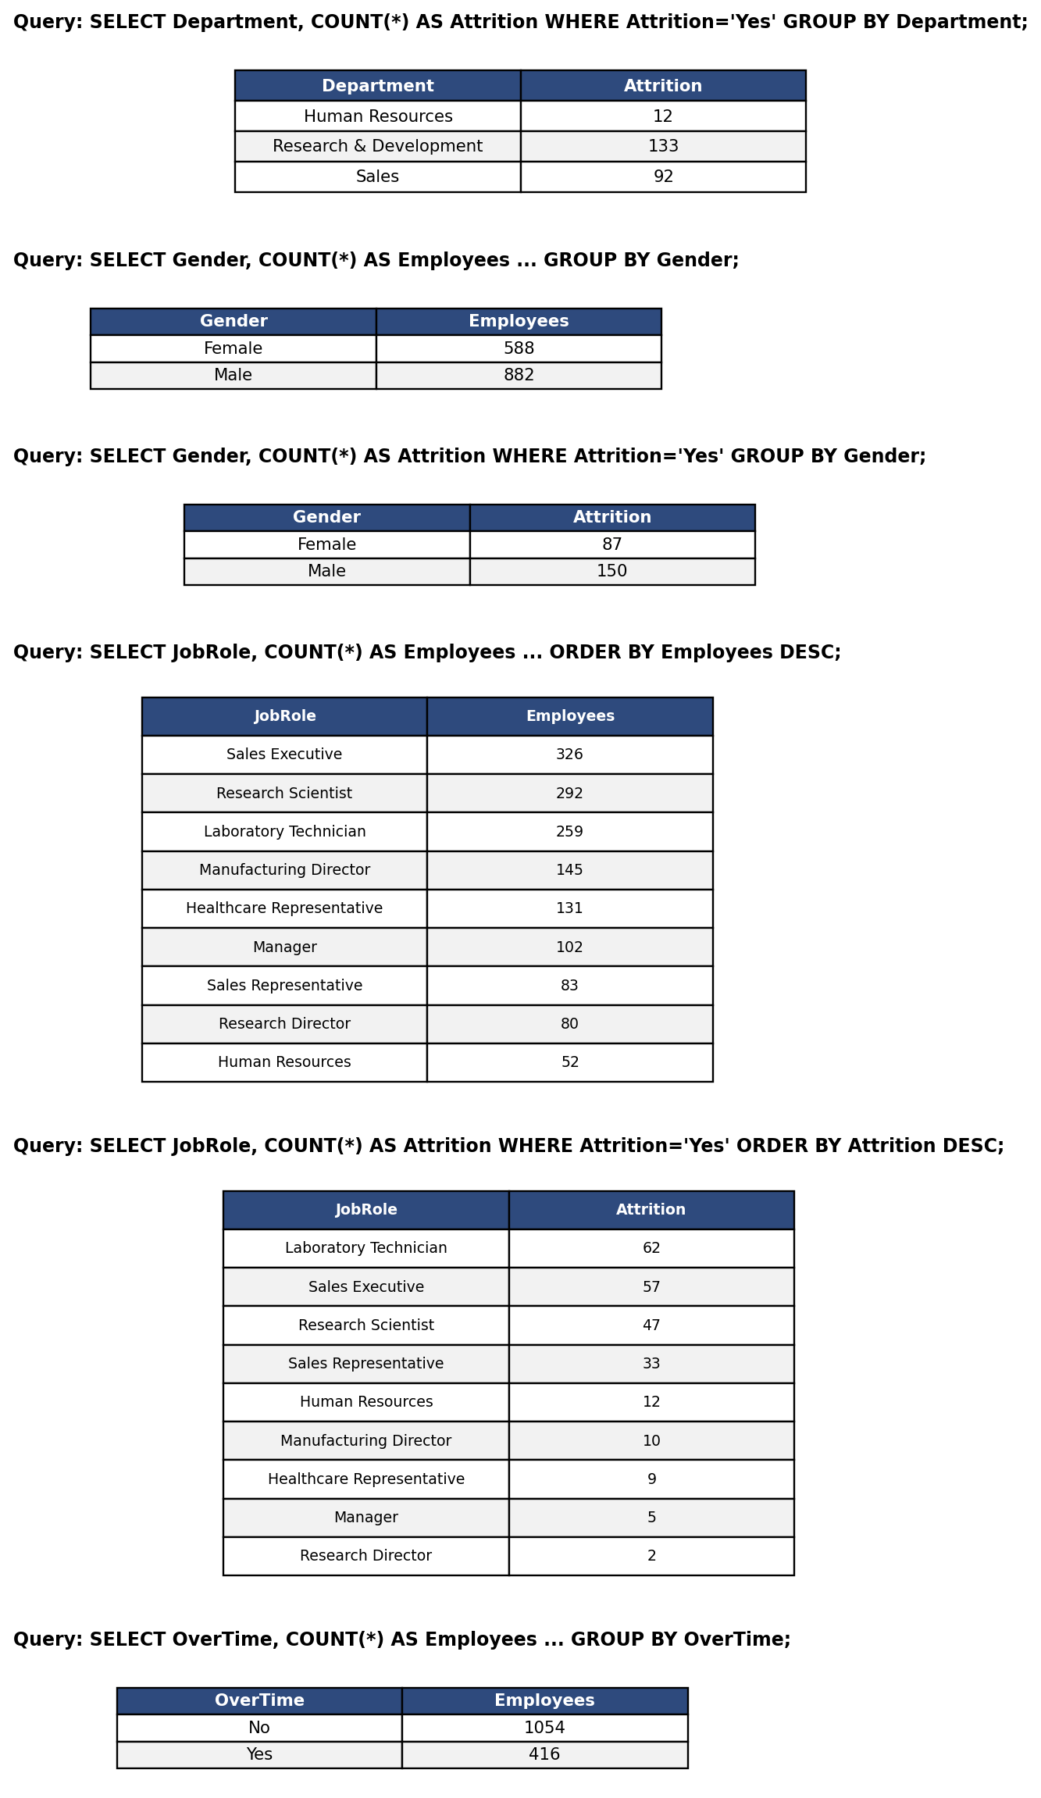
Figure 3.1 SQL Output — Total Employees, Attrition, Attrition Rate, Average Age, Average Income, Department-wise Employees, Job Role Analysis, Overtime Analysis

8.HR Analytics (Attrition, Performance & Prediction model)
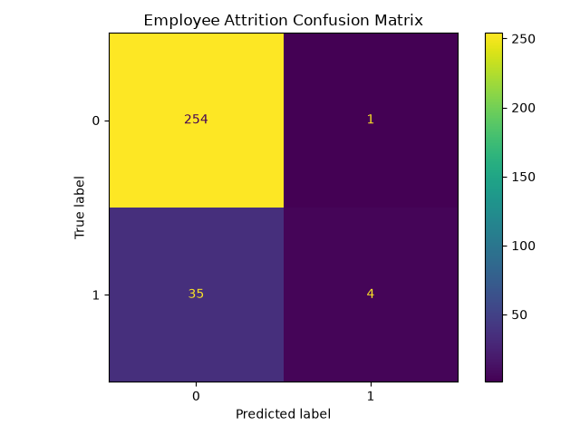
Figure 3.2 Confusion Matrix of the Employee Attrition Prediction Model (Python, Scikit-learn)

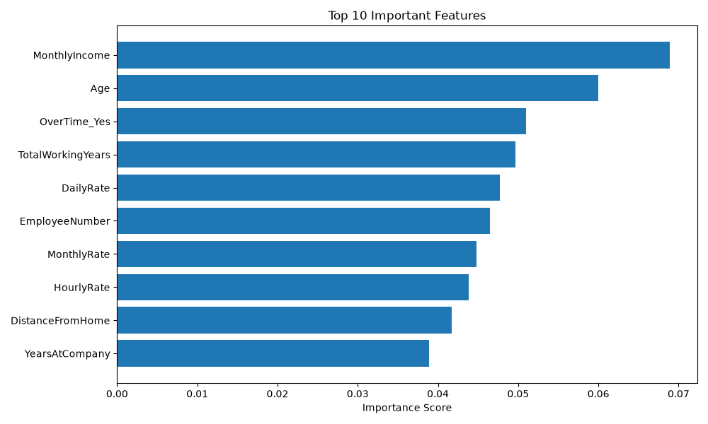
Figure 3.3 Top 10 Important Features Influencing Employee Attrition (Feature Importance Chart)
The Power BI HR Analytics dashboard developed for this project consisted of 8 report pages, including: Overview (KPI cards, department-wise and gender-wise distribution), Employee Demographics (age, education, marital status, business travel), Attrition Analysis (department-wise, job-role-wise, and overtime-based attrition), Satisfaction & Performance (job satisfaction, work-life balance, performance rating), Compensation Analysis (income by department/role, salary slab-wise attrition), and Model Results (confusion matrix and feature importance, shown above).
3.2 USE CASE DIAGRAM
The Use Case Diagram represents the interaction between the users and the HR Analytics system.
• Login/Register
• View Dashboard
• View HR Analytics
• Search Employee
• Enter Employee Details
• Predict Attrition
• View Risk Percentage
• View Risk Level
• View High-Risk Employees
• View Prediction Explanation
• View Prediction History
• View Power BI Analytics
Use Case Flow
HR User → Login → Dashboard → Employee Analysis → Prediction → Risk Result → SHAP Explanation
The HR user can also directly access employee search, high-risk monitoring, analytics, and reporting modules.
3.3 SNAPSHOTS
The following screenshots included in the final project report to demonstrate the working of the developed system.
– Registration Page
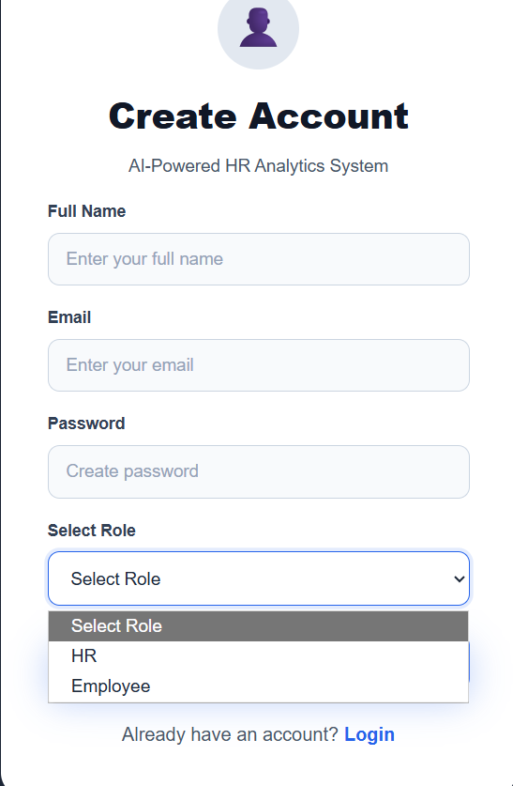
Figure 3.4: Registration interface
– HR Analytics Dashboard
The dashboard should show the major HR KPIs including:
- Total Employees
- Employees Left
- Attrition Rate
- Average Monthly Income
It should also contain charts for employee distribution and HR analytics.
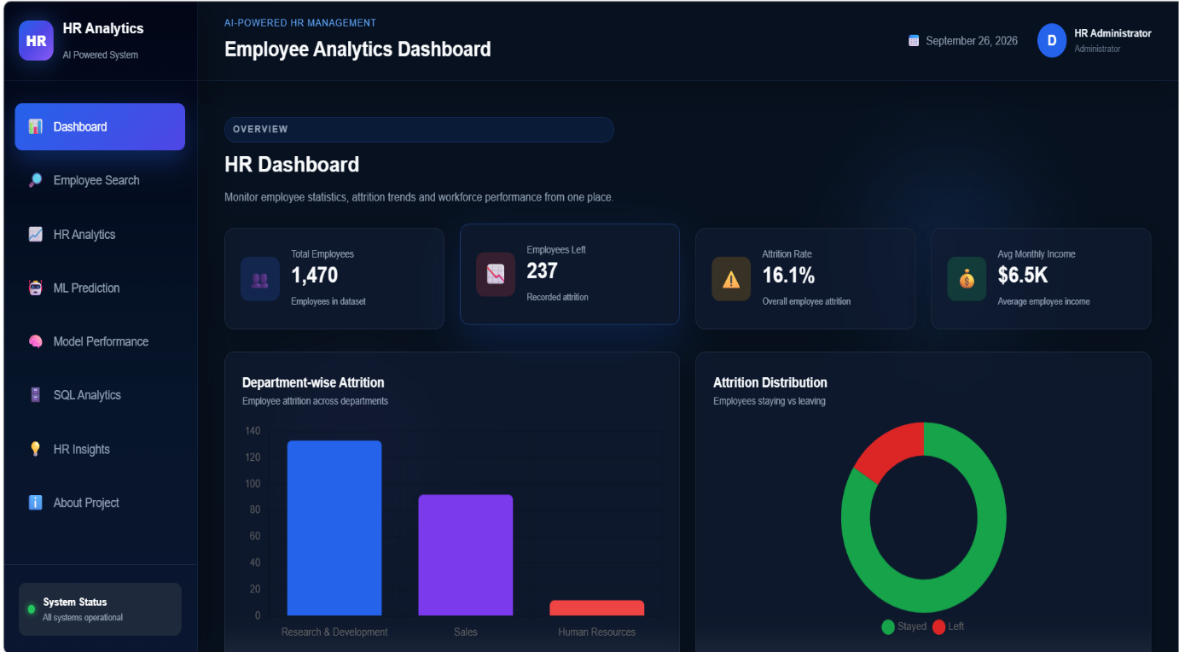
Figure 3.5: HR Employee Analytics Dashboard
– ML Prediction Form
The prediction form should contain the six primary input features:
- Age
- Monthly Income
- Years at Company
- Job Satisfaction
- Overtime
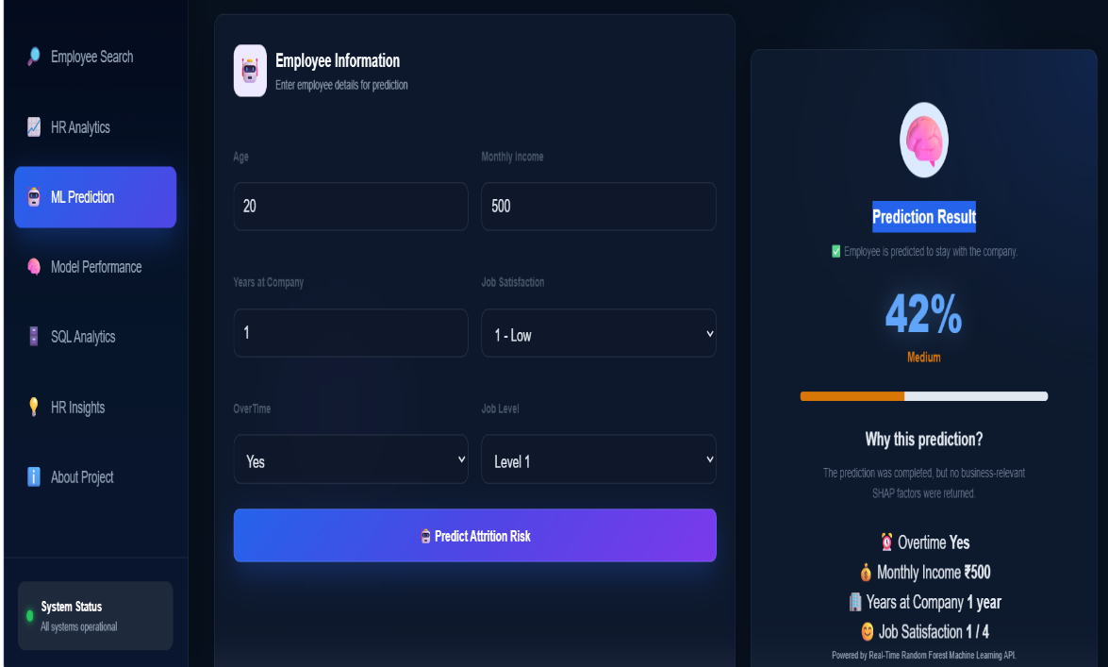
Figure3.6 – ML Prediction Form
– High-Risk Employee Monitoring
This screenshot shows employees categorized as high risk and relevant employee information for HR review.
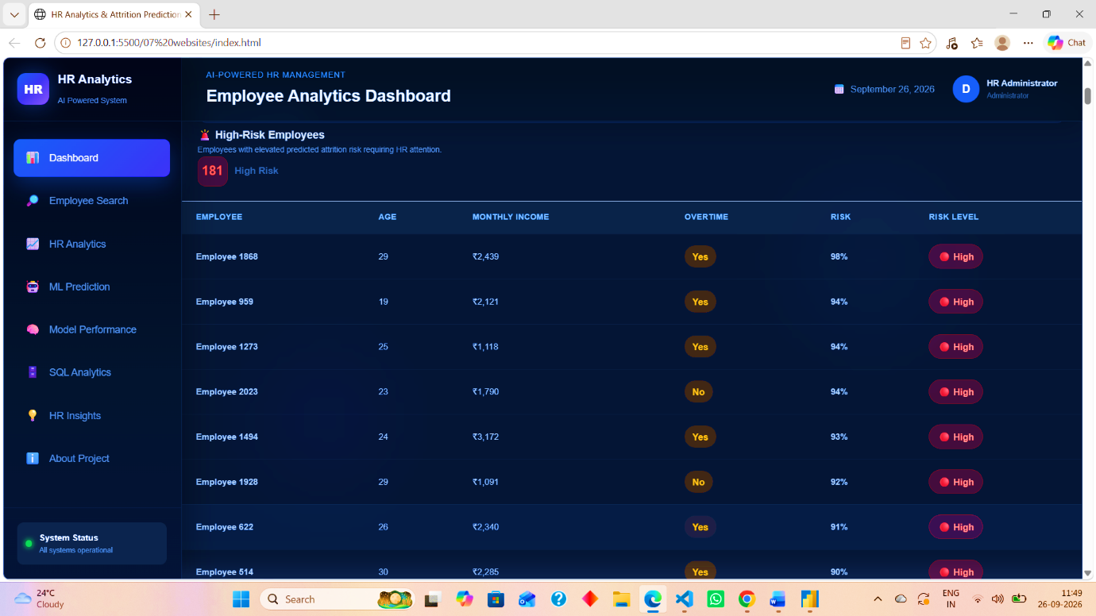
Figure3.7 – High-Risk Employee Monitoring
– Power BI Dashboard
The Power BI screenshot should demonstrate interactive HR analytics, charts, KPIs, filters, and business intelligence reporting.
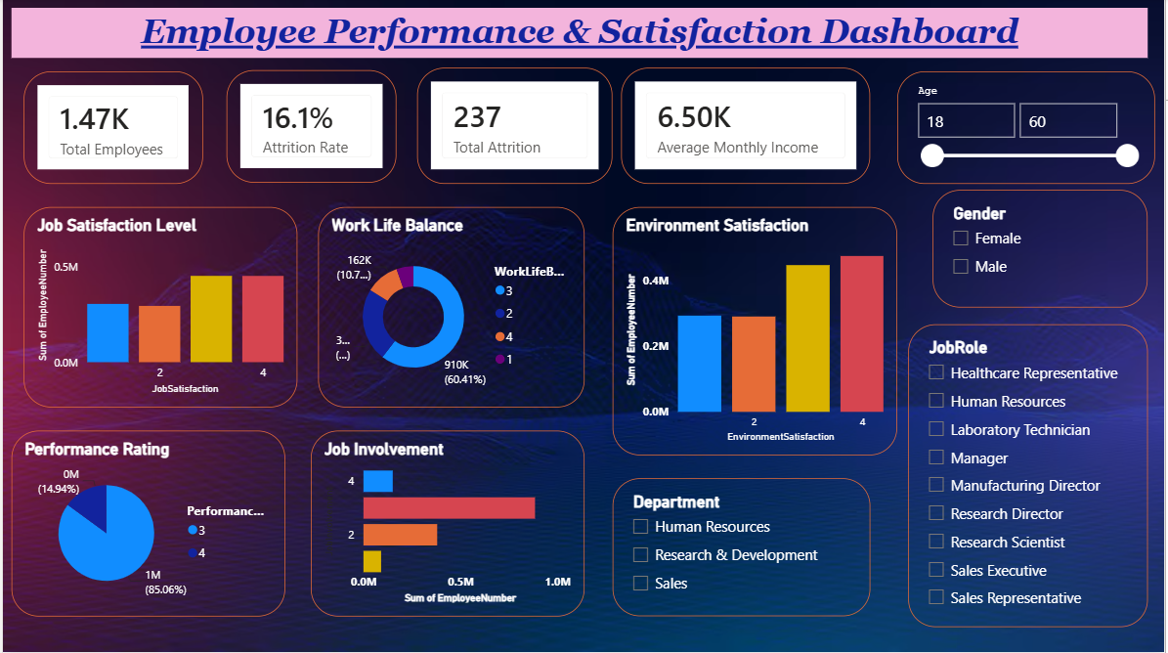
Figure3.8 Power BI Dashboard
Summary of System Design
The overall working of the proposed system can be summarized as:
Employee Data
↓
Random Forest Machine Learning Model
↓
Attrition Prediction
↓
Risk Percentage
↓
HR Dashboard
↓
SHAP Explanation + High-Risk Monitoring + Power BI Analytics
The proposed architecture integrates data analytics, Machine Learning, Explainable AI, database management, web technologies, and business intelligence into a single HR analytics platform.
CHAPTER IV
TESTING
4.1 ABOUT THE TECHNOLOGY USED
The IBM HR Analytics – Employee Attrition Prediction System is developed using a combination of web technologies, database technologies, data analytics tools, and machine learning techniques. The testing process was performed according to the individual modules as well as the complete integrated system.
The major technologies used in the developed system are Python, Fast API, MySQL, SQL Alchemy, MySQL, HTML, CSS, JavaScript, Chart.js, Scikit-learn, Random Forest, SHAP, Joblib, and Power BI.
4.2 TESTING
Testing is an important phase of software development used to verify whether the developed system works according to the specified requirements. The main purpose of testing the HR Analytics system is to identify errors, verify individual modules, validate communication between different components, and ensure that the complete application produces the expected results.
The following testing approaches were considered for the developed system:
- Unit Testing
- Integration Testing
- System Testing
The major modules tested include:
- User Login and Registration
- Role-based navigation
- Employee data processing
- Dashboard and KPI calculation
- HR analytics charts
- Employee search
- Machine learning prediction
- Risk-level calculation
- High-risk employee monitoring
- SHAP explanation
- MySQL database connectivity
- Fast API endpoints
- Power BI analytics
4.2.1 UNIT TESTING
Unit testing is performed to test individual components or modules of the system separately. Each module is tested independently to verify that it performs its intended operation correctly.
In the HR Analytics system, unit testing was applied to the main functional components.
Unit Test Case 1: User Registration
Objective: To verify that a new user can register successfully.
Input: Valid user name, email, password, and role.
Expected Result: User information should be stored successfully and the registration process should complete.
Result: Passed.
Unit Test Case 2: User Login
Objective: To verify that registered users can log in using valid credentials.
Input: Registered email and correct password.
Expected Result: Login should be successful and the user should be redirected according to the selected role.
Result: Passed
Unit Test Case 3: Employee Attrition Prediction
Objective: To verify that the prediction module accepts employee information and generates an attrition prediction.
Input: Age, Monthly Income, Job Satisfaction, Overtime, Years at Company, and Job Level.
Expected Result: The system should return the predicted attrition status and risk percentage.
Result: Passed.
Unit Test Case 4: Risk Level Calculation
Objective: To verify the classification of predicted risk into Low, Medium, and High categories.
Input: Predicted risk percentage.
Expected Result:
- Risk below 35% → Low
- Risk from 35% to below 65% → Medium
- Risk 65% or above → High
Result: Passed.
Unit Test Case 5: High-Risk Employee Detection
Objective: To verify that employees classified as high risk are correctly identified.
Input: Employee dataset and trained machine learning model.
Expected Result: Employees having a predicted risk of 65% or above should be included in the high-risk employee list.
Result: Passed.
Unit Test Case 6: SHAP Explanation
Objective: To verify that the explanation module provides the major factors influencing a prediction.
Input: Employee prediction data.
Expected Result: The system should display important contributing features for the prediction.
Result: Passed.
Unit Test Case 7: Database Connection
Objective: To verify the connection between the Fast API backend and MySQL database.
Input: Valid database configuration.
Expected Result: The system should successfully connect to the HR Analytics database and execute database operations.
Result: Passed.
Unit Test Case 8: Dashboard Summary
Objective: To verify that dashboard KPIs and analytics data are correctly retrieved.
Input: Employee dataset/database records.
Expected Result: Total employees, employees who left, attrition rate, average monthly income, and other analytics should be displayed correctly.
Result: Passed.
4.2.2 INTEGRATION TESTING
Integration testing is performed after individual modules have been tested. The purpose of integration testing is to verify that different modules communicate correctly with each other.
In the HR Analytics system, several components work together. The frontend communicates with the Fast API backend, the backend communicates with the machine learning model and MySQL database, and the prediction module communicates with the SHAP explanation module.
Integration Testing Areas
1. Frontend and Backend Integration
The frontend prediction form was integrated with the Fast API /predict endpoint.
Process:
Frontend Form → Fast API → Random Forest Model → Prediction Result → Frontend
Expected Result: The entered employee information should be successfully sent to the backend and the prediction should be displayed on the frontend.
Result: Passed.
2. Backend and Machine Learning Model Integration
The Fast API backend was integrated with the trained employee_attrition_model.pkl file.
Process:
Employee Features → Backend → Random Forest Model → Probability → Risk Percentage → Risk Level
Expected Result: The backend should load the trained model and return a valid prediction.
Result: Passed.
3. Backend and MySQL Integration
The Fast API backend was integrated with the MySQL HR Analytics database.
Process:
Frontend Request → Fast API → SQL Alchemy/MySQL → MySQL → Data → Fast API → Frontend
Expected Result: Employee information and analytical data should be retrieved successfully.
Result: Passed.
4. Prediction and SHAP Integration
The prediction module was integrated with the SHAP explanation functionality.
Process:
Employee Data → Prediction Model → Prediction → SHAP Analysis → Important Features → Explanation
Expected Result: After generating a prediction, the system should provide meaningful factors related to the prediction.
Result: Passed.
5. High-Risk Monitoring Integration
The high-risk employee module was integrated with the prediction system.
Process:
Employee Dataset → Batch Prediction → Risk Percentage → Risk Classification → High-Risk Employee List
Expected Result: Employees classified as High Risk should be displayed in the AI Risk Monitoring section.
Result: Passed.
4.2.3 SYSTEM TESTING
System testing is performed on the complete application to verify whether all components work together according to the requirements.
The complete HR Analytics system was tested from the user's perspective. The testing covered authentication, dashboard analytics, employee search, machine learning prediction, risk monitoring, database operations, and explanation functionality.
System Test Cases
Test Case | Test Scenario | Expected Result | Result
ST-01 | Open Login Page | Login page should load correctly | Passed
ST-02 | Register New User | User should be registered successfully | Passed
ST-03 | Login with Valid Credentials | User should log in successfully | Passed
ST-04 | Login with Invalid Credentials | Error message should be displayed | Passed
ST-05 | HR Login | HR dashboard should open | Passed
ST-06 | Employee Login | Employee portal should open | Passed
ST-07 | Load Dashboard | Dashboard should display correctly | Passed
ST-08 | Display KPI Cards | HR KPIs should be displayed | Passed
ST-09 | Display Analytics Charts | Charts should load correctly | Passed
ST-10 | Search Employees | Matching employee records should be displayed | Passed
ST-11 | Submit Prediction Form | Prediction should be generated | Passed
ST-12 | Calculate Risk Percentage | Risk percentage should be displayed | Passed
ST-13 | Display Risk Level | Low/Medium/High level should be displayed | Passed
ST-14 | Display High-Risk Employees | High-risk employees should be listed | Passed
ST-15 | Generate SHAP Explanation | Important prediction factors should be displayed | Passed
ST-16 | Test Database Connection | Database connection should work | Passed
ST-17 | SQL Analytics | SQL-based information should be displayed | Passed
ST-18 | Prediction History | Previous predictions should be displayed | Passed
ST-19 | Power BI Dashboard | Interactive HR analytics should be available | Passed
ST-20 | Responsive Interface | Interface should remain usable on different screen sizes | Passed
Machine Learning Model Testing
The final Random Forest model was also evaluated using a separate test dataset. The dataset was divided into 80% training data and 20% testing data.
- Total records: 1,470
- Training records: 1,176
- Testing records: 294
- Selected features: 6
- Model: Random Forest
- Test Accuracy: 77.55%
The classification results of the implemented model were:
Class | Precision | Recall | F1-Score
No Attrition | 0.87 | 0.86 | 0.87
Attrition | 0.31 | 0.32 | 0.31
The testing confirms that the machine learning component is successfully integrated into the web application and produces prediction results for employee attrition risk.
Overall Testing Result
The testing process verified the major functional and technical components of the IBM HR Analytics – Employee Attrition Prediction System. Individual modules were tested using unit testing, communication between modules was verified using integration testing, and the complete application was evaluated using system testing.
The testing covered the authentication module, employee analytics dashboard, database connectivity, machine learning prediction, risk classification, high-risk employee monitoring, SHAP-based explanation, employee search, prediction history, and Power BI analytics.
Based on the performed tests, the developed system successfully performs its intended HR analytics and employee attrition prediction functions.

CHAPTER V:
ADVANTAGES AND LIMITATIONS OF THE DEVELOPED SYSTEM
5.1 ADVANTAGES
The IBM HR Analytics – Employee Attrition Prediction System provides a combination of HR analytics, machine learning, database management, web-based visualization, and explainable artificial intelligence. The major advantages of the developed system are described below.
5.1.1 Employee Attrition Prediction
The system uses a Random Forest machine learning model to predict whether an employee is likely to leave the organization. The prediction is based on important employee-related attributes such as Age, Monthly Income, Job Satisfaction, Overtime, Years at Company, and Job Level.
This allows HR personnel to identify potential attrition cases before they become actual employee exits.
5.1.2 Risk Percentage and Risk Classification
The system provides a predicted risk percentage along with a risk category.
The risk is classified into three levels:
- Low Risk: Below 35%
- Medium Risk: 35% to below 65%
- High Risk: 65% or above
This makes machine learning results easier for HR users to understand and interpret.
5.1.3 AI-Based High-Risk Employee Monitoring
The system includes an AI Risk Monitoring module that identifies employees with high predicted attrition risk. Instead of checking employees individually, HR personnel can view high-risk employees in a dedicated section of the dashboard.
This can help HR teams prioritize employees who may require attention or further evaluation.
5.1.4 HR Analytics Dashboard
The system provides a centralized HR analytics dashboard containing important employee and attrition-related information.
The dashboard includes:
- Total Employees
- Employees Who Left
- Attrition Rate
- Average Monthly Income
- Department Analysis
- Job Role Analysis
- Gender Distribution
This reduces the need to manually analyse raw employee data.
5.1.5 Explainable AI Using SHAP
The system does not only provide a prediction; it also provides an explanation of the prediction using SHAP-based analysis.
The explanation identifies important factors influencing the prediction, such as OverTime, Monthly Income, Job Satisfaction, Years at Company, and other selected features.
This improves the transparency of the machine learning system and helps users understand why a particular prediction was generated.
5.1.6 Employee Search and Filtering
The employee search functionality allows HR users to filter employee records using criteria such as:
- Department
- Job Role
- Gender
- OverTime
- Attrition
This makes it easier to locate and analyze specific groups of employees.
5.1.7 Role-Based User Interface
The system provides separate access flows for HR users and employees.
After login:
- HR users are directed to the HR Analytics Dashboard.
- Employee users are directed to the Employee Portal.
This provides different functionality according to the user's role.
5.1.8 Database Integration
The system is integrated with a MySQL database through the Fast API backend using SQL Alchemy and MySQL. This provides structured storage and retrieval of employee-related information and supports SQL-based analytics.
5.1.9 Fast API-Based Backend
Fast API provides a structured backend API for communication between the frontend, database, and machine learning model.
The backend supports operations such as:
- Employee search
- Attrition prediction
- High-risk employee detection
- SHAP explanation
- Database health checking
This modular architecture makes the application easier to maintain and extend.
5.1.10 Reduction of Manual Analysis
Traditional HR analysis may require manual examination of large employee datasets. The developed system automates several operations such as data analysis, prediction, risk classification, employee filtering, and high-risk employee identification, thereby reducing repetitive manual work.
5.2 LIMITATIONS
Although the IBM HR Analytics – Employee Attrition Prediction System provides several useful capabilities, it also has certain limitations. These limitations are mainly related to the dataset, machine learning model, authentication implementation, and deployment environment.
5.2.1 Limited Dataset Size
The system is developed using the IBM HR Employee Attrition dataset containing 1,470 employee records and 35 attributes. Since the dataset is limited in size and scope, the model may not represent every possible employee situation in a real organization.
5.2.2 Dataset-Specific Model
The machine learning model is trained using the IBM HR dataset. Therefore, its predictions are dependent on the patterns present in that dataset. If the system is applied to a different organization, the model may require retraining using organization-specific employee data.
Other potentially relevant HR factors are not directly used by the final prediction model. Therefore, the model does not consider every attribute available in the original dataset when generating the prediction.
5.2.3 Model Performance Limitation
The final six-feature Random Forest model achieved an accuracy of 77.55% on the test dataset. Although this demonstrates useful predictive capability, it also indicates that the model can make incorrect predictions.
Therefore, the generated risk percentage should be treated as a decision-support indicator rather than a guaranteed prediction of employee behaviour.
5.2.4 Risk Thresholds Are Predefined
The Low, Medium, and High-risk categories are based on predefined thresholds:
- Below 35% – Low
- 35% to below 65% – Medium
- 65% or above – High
These thresholds are application-defined and may need to be recalibrated for a particular organization's HR requirements and risk tolerance.
5.2.5 Prediction Does Not Explain Employee Intent
The system predicts attrition risk from available employee attributes. It cannot directly determine an employee's actual intention to leave the organization.
Factors such as personal circumstances, career plans, workplace relationships, external opportunities, and other unrecorded factors may influence actual employee decisions.
5.2.6 Dependence on Data Quality
The quality of machine learning predictions depends on the quality of the input data. Missing, incorrect, outdated, or inconsistent employee information can affect analytical results and prediction quality.
5.2.7 Internet/Deployment Requirements
For a complete deployed version, the frontend, backend API, database, and other services must be properly hosted and configured. Problems with server availability, database connectivity, or API connectivity can affect system functionality.
Summary
The developed IBM HR Analytics – Employee Attrition Prediction System provides a unified platform for HR analytics, employee attrition prediction, risk monitoring, explainable AI, database operations, and business intelligence. Its major strengths include automated analysis, machine learning-based risk prediction, SHAP explanations, high-risk employee monitoring, interactive dashboards, and Power BI analytics.
At the same time, the system has limitations related to dataset size, feature selection, model performance, data dependency, authentication implementation, predefined risk thresholds, and the absence of real-time organizational data. These limitations provide opportunities for further improvement and expansion of the system in future versions.

CHAPTER VI
RESULTS, CONCLUSION AND FUTURE SCOPE
The successful completion of the AI-Powered HR Analytics & Employee Attrition Prediction System demonstrates the practical application of Artificial Intelligence, Machine Learning, Database Management Systems, SQL, and Business Intelligence in Human Resource Management. The project was developed to analyse employee-related information, predict employee attrition, and generate meaningful business insights for HR professionals.
Throughout the project, the IBM HR Analytics dataset was analysed using Python for data preprocessing and machine learning, MySQL for database management and SQL analysis, and Microsoft Power BI for interactive dashboard visualization. The combination of these technologies enabled the development of a comprehensive HR Analytics system capable of supporting data-driven decision-making.
This chapter presents the project results, discusses the overall conclusion, highlights the advantages of the developed system, and suggests future enhancements.
6.1 Results Obtained
The project successfully achieved all the objectives defined at the beginning of the research. The implementation of Python, MySQL, and Power BI enabled efficient analysis of employee data and prediction of employee attrition.
The major outcomes of the project are as follows:
- Successfully imported and analysed the IBM HR Analytics dataset containing 1470 employee records.
- Performed data preprocessing and exploratory data analysis using Python.
- Built a machine learning model to predict employee attrition.
- Designed and implemented a MySQL database for employee data management.
- Executed 25 SQL queries to generate HR-related business insights.
- Developed an interactive Power BI dashboard for workforce analysis.
- Identified important factors influencing employee attrition, including overtime, monthly income, work-life balance, job satisfaction, and years at the company.
- Generated visual reports that support HR managers in strategic workforce planning.
The developed system successfully integrates predictive analytics with business intelligence, making it suitable for practical HR applications.
6.2 Project Achievements
The project achieved several technical and analytical objectives, including:
- Development of an AI-based employee attrition prediction system.
- Successful implementation of data preprocessing techniques.
- Comprehensive exploratory data analysis.
- SQL-based HR analytics using MySQL.
- Interactive dashboard development using Microsoft Power BI.
- Generation of meaningful business insights for Human Resource Management.
- Integration of Python, SQL, and Power BI into a single analytical framework.
These achievements demonstrate the practical application of modern data analytics techniques in solving real-world HR problems.
6.3 Future Scope
Although the proposed system provides effective employee attrition analysis and prediction, several improvements can be made in future versions.
The future scope of the project includes:
- Integration of real-time employee databases.
- Deployment as a web-based HR Analytics application.
- Development of mobile-based HR dashboards.
- Implementation of Deep Learning algorithms for improved prediction accuracy.
- Integration with cloud platforms such as Microsoft Azure or AWS.
- Automatic report generation using Artificial Intelligence.
- Real-time employee performance monitoring.
- Employee sentiment analysis using Natural Language Processing (NLP).
- Integration with payroll and attendance management systems.
- Development of AI-based HR recommendation systems for employee retention.
These enhancements can further improve the accuracy, scalability, and practical usefulness of the system.
6.4 Recommendations
Based on the analysis performed during the project, the following recommendations are suggested for organizations:
- Monitor employee overtime regularly to reduce burnout.
- Improve work-life balance policies.
- Provide career growth and promotion opportunities.
- Conduct periodic employee satisfaction surveys.
- Offer competitive salary packages based on performance.
- Identify high-risk employees using predictive analytics.
- Use interactive dashboards for continuous workforce monitoring.
- Adopt AI-driven HR decision-support systems to improve employee retention.
Implementing these recommendations can help organizations reduce attrition, improve employee engagement, and enhance overall organizational performance.

CONCLUSION
The IBM HR Analytics dataset containing 1,470 employee records and 35 attributes was used throughout the project. The dataset was first cleaned and pre-processed using Python to improve data quality and ensure reliable analysis. Exploratory Data Analysis (EDA) was then performed to understand employee behaviour and identify the key factors influencing attrition. The analysis revealed that variables such as Overtime, Monthly Income, Job Satisfaction, Work-Life Balance, Job Level, Years at Company, and Total Working Years have a significant impact on employee attrition.
A Machine Learning model was developed to predict whether an employee is likely to leave the organization. The implementation demonstrated that predictive analytics can help organizations identify employees who are at a higher risk of resignation before they actually leave. Such predictions enable HR managers to take proactive measures, including career development opportunities, employee engagement programs, improved work-life balance initiatives, and performance-based incentives.
To strengthen the analytical capability of the project, a relational database was developed using MySQL. The employee dataset was imported into the database, and 25 SQL queries were executed successfully to generate meaningful HR reports. These queries helped analyze employee demographics, departmental distribution, salary trends, overtime patterns, job roles, and employee attrition. SQL analysis provided structured business insights that complemented the machine learning results.
Furthermore, an interactive dashboard was developed using Microsoft Power BI. The dashboard included KPI cards, department-wise employee distribution, gender analysis, attrition analysis, salary distribution, and overtime analysis. These visualizations transformed raw employee data into meaningful graphical reports, making it easier for HR managers to understand workforce trends and make strategic decisions.
Overall, the proposed HR Analytics system successfully integrates Python, Machine Learning, MySQL, SQL, and Microsoft Power BI into a unified platform. The project not only predicts employee attrition but also provides valuable analytical insights that can support employee retention strategies, improve workforce planning, and reduce organizational costs associated with employee turnover.

REFERENCES
- IBM. (2016). IBM HR Analytics Employee Attrition & Performance Dataset.
- Geron, A. (2019). Hands-On Machine Learning with Scikit-Learn, Kera’s & TensorFlow (2nd ed.). O'Reilly Media.
- McKinney, W. (2022). Python for Data Analysis (3rd ed.). O'Reilly Media.
- Pedregosa, F., et al. (2011). Scikit-learn: Machine Learning in Python. Journal of Machine Learning Research, 12, 2825–2830.
- Microsoft Corporation. (2024). Microsoft Power BI Documentation.
- Oracle Corporation. (2024). MySQL Reference Manual.
- Pandas Development Team. (2024). Pandas Documentation.
- NumPy Developers. (2024). NumPy User Guide.
- Matplotlib Development Team. (2024). Matplotlib Documentation.
- Han, J., Kamber, M., & Pei, J. (2012). Data Mining: Concepts and Techniques (3rd ed.). Morgan Kaufmann

